Calendly Guidance – Availability
TROUBLESHOOT TOOL:
- In the ‘Booking Page’ view, click on the Troubleshoot button.
- Select the date you think should be available.
It should give you an idea of why this date/time is unavailable, E.g. this day is set as unavailable in your calendar or it overlaps with another event in your calendar.
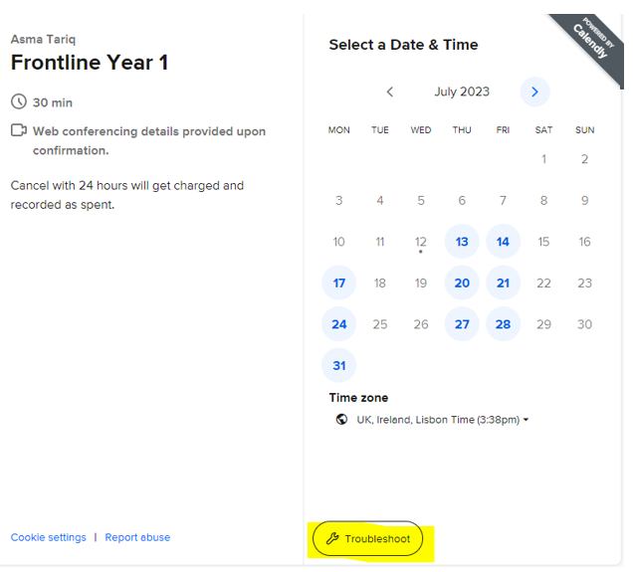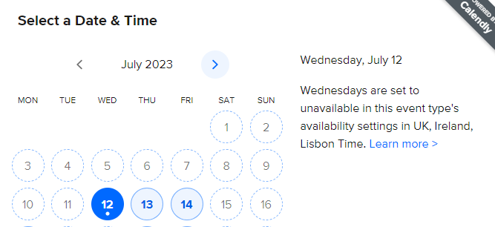

- You can click on ‘details’ to see why a specific time on that date is unavailable.
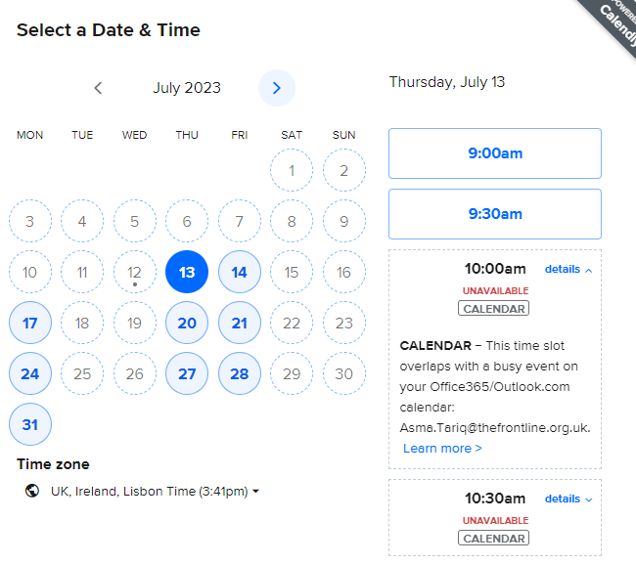

- If you have an event in your calendar, but you do not want the day/time blocked out (i.e. reminders, birthday etc.) – then ensure the event in your calendar is set a ‘free’ and not ‘busy’.

In Outlook you need to right click on the event and in ‘show as’ select ‘Free’.
The event will remain in your calendar but appear as free – so making you available at this time.
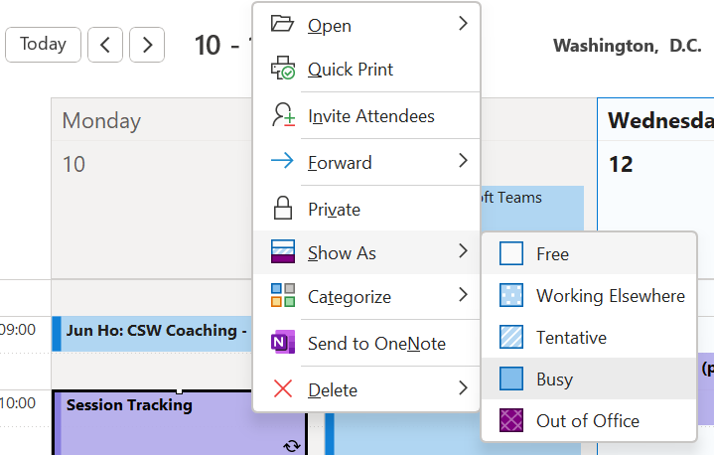

In the EVENT SETTINGS:
- Date Range
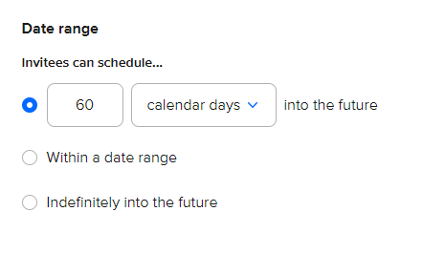
- The default is set to showing availability for ‘60 days into the future.
- If you are happy for participants to be able to book at any time you can change to ‘Indefinitely into the future’ or ‘within a date range’ (if you want to keep within session windows).

- Duration

- Check the duration is long enough – with events set up as ad-hoc (which we don’t encourage!), the duration will need to be updated to reflect the length of the session.

- Schedule – use an existing schedule

- You can set your days & hours as the regular days you are free or unavailable.
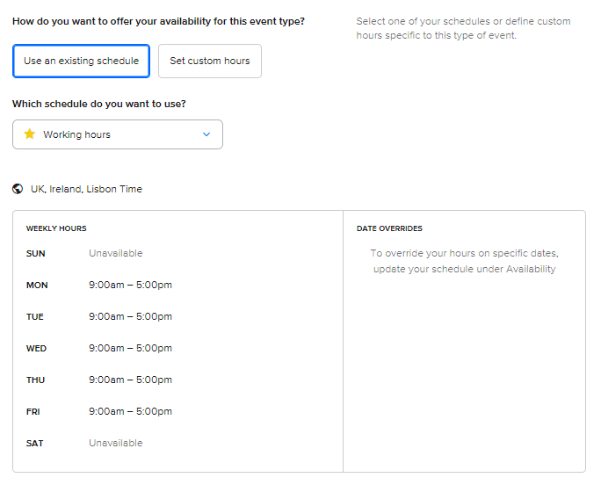
- Schedule – Set custom hours

- If there are dates or times you would like to block out (i.e. for holidays or other commitments) then select ‘Set custom hours’ and ‘Add a date override’

- You can set full days as unavailable or change the hours for a date (i.e. you want to book a session earlier than your normal hours e.g. 9am instead of 10am)

- If you only want the ‘override dates/times’ to be used – deselect the check boxes in the weekly hours.
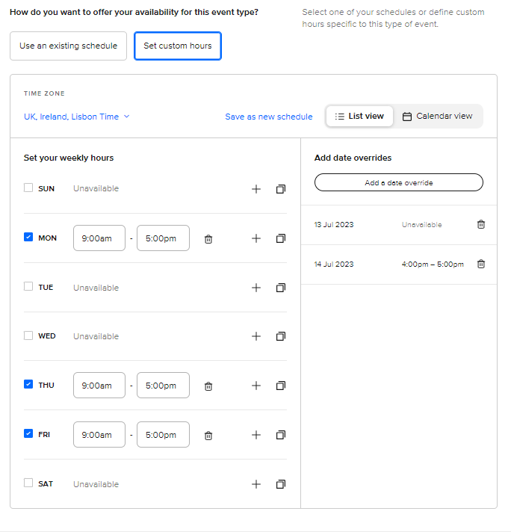

- Buffer time:

- You can choose to have a buffer time before/after meetings – so they do not all run concurrently. This may be a reason why you are not available at a certain time. You can deselect the check boxes if you do not mind.

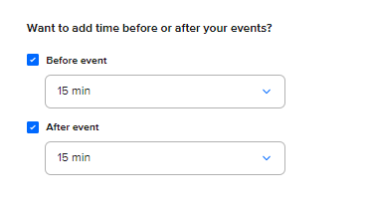

- Additional Rules:

- Click on the down arrow to see additional rules for your availability.

- The default is set to increments of 30 mins – this can be changed to your preference.

- The default is set so invitees can not book within 4 hours of an event time. If you would like an invitee to be able to book at short notice, or more than 4 hours, then you can amend this time.

