Public narrative

Deliberate practice session guidance for coaches – Pathway 2, Cohort 4
Running between 27 November - 8 December

What is public narrative?
Public narrative is a tool for leaders created by Marshall Ganz, a Harvard lecturer. He recognised that stories are a natural way in which we make sense of the world, and that through storytelling people can be brought together around a common goal and motivated into action. Stories connect not only with our hearts but with our heads and follow a structure with which we are familiar and have the capacity to make connections and bring us together. If leaders create their own narrative, they have an opportunity to connect with and inspire the people they work alongside.

What will leaders know and bring to your session?
Leaders will have completed a newly designed self-directed online module on public narrative. The outcomes for this self-directed module are:
- Develop an understanding of public narrative and consider its relevance and applicability within your own approach to leadership
- Write your own public narrative and prepare to practice with colleagues in your first deliberate practice group session

Leaders will have been introduced to the concept of deliberate practice at the end of the public narrative module. The following is taken from the module:

Deliberate practice provides a structure to practice specific skills, making implementing new techniques into practice more likely and effective. You will have three deliberate practice sessions across the Pathways programme. In your first deliberate practice session, you and your colleagues will have the opportunity to practice your public narrative and receive feedback from your peers. We would like your final narrative to be around 3-4 minutes in speech, and no longer than 5 minutes.

What are the outcomes of your session?
By the end of your session, leaders will have:
- Practised their prepared public narrative.
- Received feedback from their peers and had the opportunity to re-practise based on that feedback.
- Developed confidence and the ability to apply public narrative in their work as a leader.

How the session will be organised
A Pathways member of staff will open the online workshop room and introduce the session to all leaders. You will then be placed in your deliberate practice breakout group with 5 leaders for the duration of the session. Please follow the structure below:
STEP 1
Warm the context – 7 minutes
Share the outcomes of the session and remind leaders of the purpose and role of deliberate practice (See information above). Share with leaders that when listening to their peers you want them to consider the success criteria as a framework for their feedback. Share the success criteria in the chat:
Success criteria
- Story of now – A clear vision or call to action is offered
- Story of us – There is clarity in who the story is for and who the presenter is looking to connect with
- Story of self – The presenter’s values and identity are clear in their narrative
Explain how the session is structured (see below). Leaders will have 15 minutes each – 4 minutes to present their public narrative, 6 minutes for you and the group to offer feedback based on the success criteria and 4 minutes to practice a second time. Please take responsibility for timings.

STEP 2
Practice time – 75 minutes (approx 15 minutes per leader)
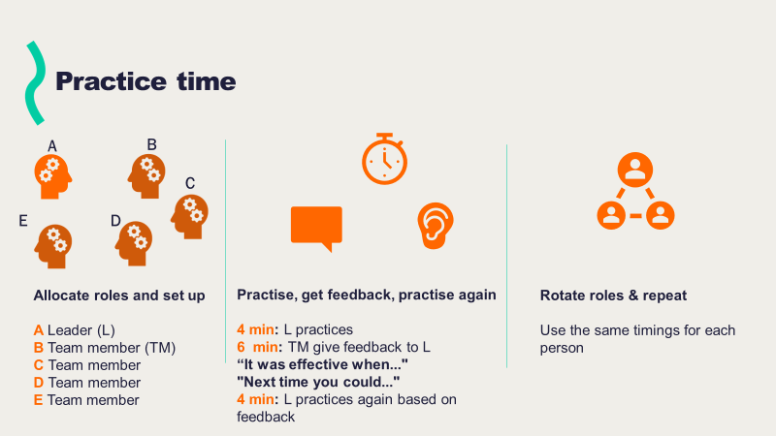
STEP 3
Reflection and next steps – 10 minutes
Reflection to possibly include:
- Your reflections from floating between breakout rooms
- Hearing from leaders how using deliberate practice helped them hone their public narrative.
- Hearing from leaders about how they could use public narrative in their practice.
- Considering with leaders what other contexts there could be to use their public narrative.

What snags or sticking points might you want to be aware of?
- Not sticking to timings – Please instruct the leaders to nominate a timer for each practice. It is very important they stick to the structure.
- Coming without a public narrative/not having fully understood what public narrative is – Please ask them to go last so they have some opportunity to see how others have done it
- Not wanting to ‘do it’ / Talking about the task rather than engaging in deliberate practice – Allay fears by creating a safe space, discussing the benefits of practice and how it’s an opportunity to ‘fly the plane without any passengers on it!’

