Deliberate practice: General principles

What is deliberate practice?
In summary it is an approach to practising skills “using activities that maximise improvement throughout development toward expert performance” (Ericsson et al., 1993). It’s about engaging in activities where the practitioner deliberately, purposefully, and mindfully seeks out new challenges to enhance his or her expertise in ways that require sharp concentration and real effort.
Doug Lemov is the author of Practice Perfect based on the application of Ericsson’s research to the field of education. In the introduction he explains the value of this methodology:
Practice doesn’t make perfect. Practice makes permanent. For example, you have been shampooing your hair for decades and yet you are not getting any better at it. (As a matter of fact, you will likely die not knowing if there was a better shampooing technique). The mere fact of doing something repeatedly does not help us improve. What we need is real practice – not just repetition. As Michael Jordan says, “you can practise shooting [basketball] hoops eight hours a day, but if your technique is wrong, then all you become is very good at shooting the wrong way”. Practice makes permanent.
As kids we were constantly practising something: playing an instrument, learning a subject a school, doing sport. Those practices could be a drag but if they were thoughtfully designed, they came with a wonderful payoff: the certainty of improvement, we couldn’t help but get better.
Practice is as important for our roles now as it was in our early education or hobbies, and there’s a long list of skills we’d be wise to hone, such as how to run a meeting that doesn’t drag on, how to listen (really listen) to others, how to build effective working relationships etc.
The enemies of practice are fear and pride and self-satisfaction. To practice requires humility. It forces us to admit we don’t know everything and to submit to feedback from someone who can teach us. To practice isn’t to declare “I’m bad” but to declare “I can be better”.

The five principles of deliberate practice
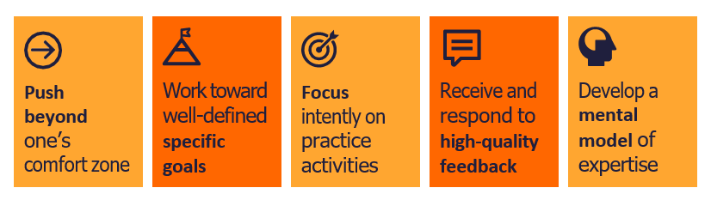

What does deliberate practice look like?
- Deliberate practice requires the ‘thing’ you’re practising to have clearly defined success criteria (principles of good practice) that you can learn and then apply to your own practice.
- It involves breaking a skill down into all of the component pieces until each element of a more complex action has been identified. To learn this skill for the first time or to improve performance, an aspect of the skill can be considered in isolation and practised until fluency is achieved. The individual skills can then be combined to increase complexity and build towards an authentic application.
- Repetition and re-practising purposefully are key – the purpose of this approach is for a skill to become completely automatic, such that, in the face of a new or challenging context, you can swing into a well-honed routine and apply good practice while your brain (working memory) is free to respond to the situation in front of you. This is especially crucial for social work where the work is incredibly demanding, you need to respond to the unexpected and situations are often emotionally challenging which can interrupt your ability to think and respond.

What is it not and common pitfalls
Deliberate practice isn’t just a role-play.
The term role-play is sometimes used to describe activities seen in deliberate practice sessions. We intentionally avoid this term for a few reasons:
- You’re not playing a ‘role’, you are yourself. Some people have termed this “real-play” but equally it’s not ‘play’, it’s a serious effort to improve your techniques and skills.
- Role-play typically doesn’t have the same level of focus as deliberate practice, often covering a number of skills being used together and not being precise about a specific isolated concept. This means there are far too many features of best practice to consider to be manageable or to allow for precise and focussed feedback.
- Role-play often has negative associations and isn’t always taken seriously for improvement as it doesn’t always have clearly defined ‘success criteria’ (principles of good practice) so therefore lacks the precise ‘granular’ feedback of deliberate practice.
- Repetition and re-practise of one element is not usually a feature of role-play. You tend to jump into the ‘game’ situation and skip over the practise drills, only having a go at the activity once.
Some other common errors to avoid in relation to practising are:
- Simply practising something that you want to do better without a clear goal.
- Practising and/or repetition of an action independently without feedback/correction
- Reflection/discussion of a topic without a specific developmental focus
- Casual practise without concentrating on the features of success and whether they’re improving.
- ‘Going through the motions’ without full effort or concentration.
- Discussion about practice, for instance, you shouldn’t be talking about ‘it’ or WHAT you would/should/could do. Instead, you should be ‘doing’ it, having a go at putting it into action.

Example structure to follow
To practise effectively, you will need to ensure you have:
- a clearly defined skill with agreed success criteria
- someone with appropriate experience to give you feedback.
- a safe space and a low demand scenario that doesn’t distract you from practice by being too complex.
You might also need someone to play another role, especially if the skill is communication based.

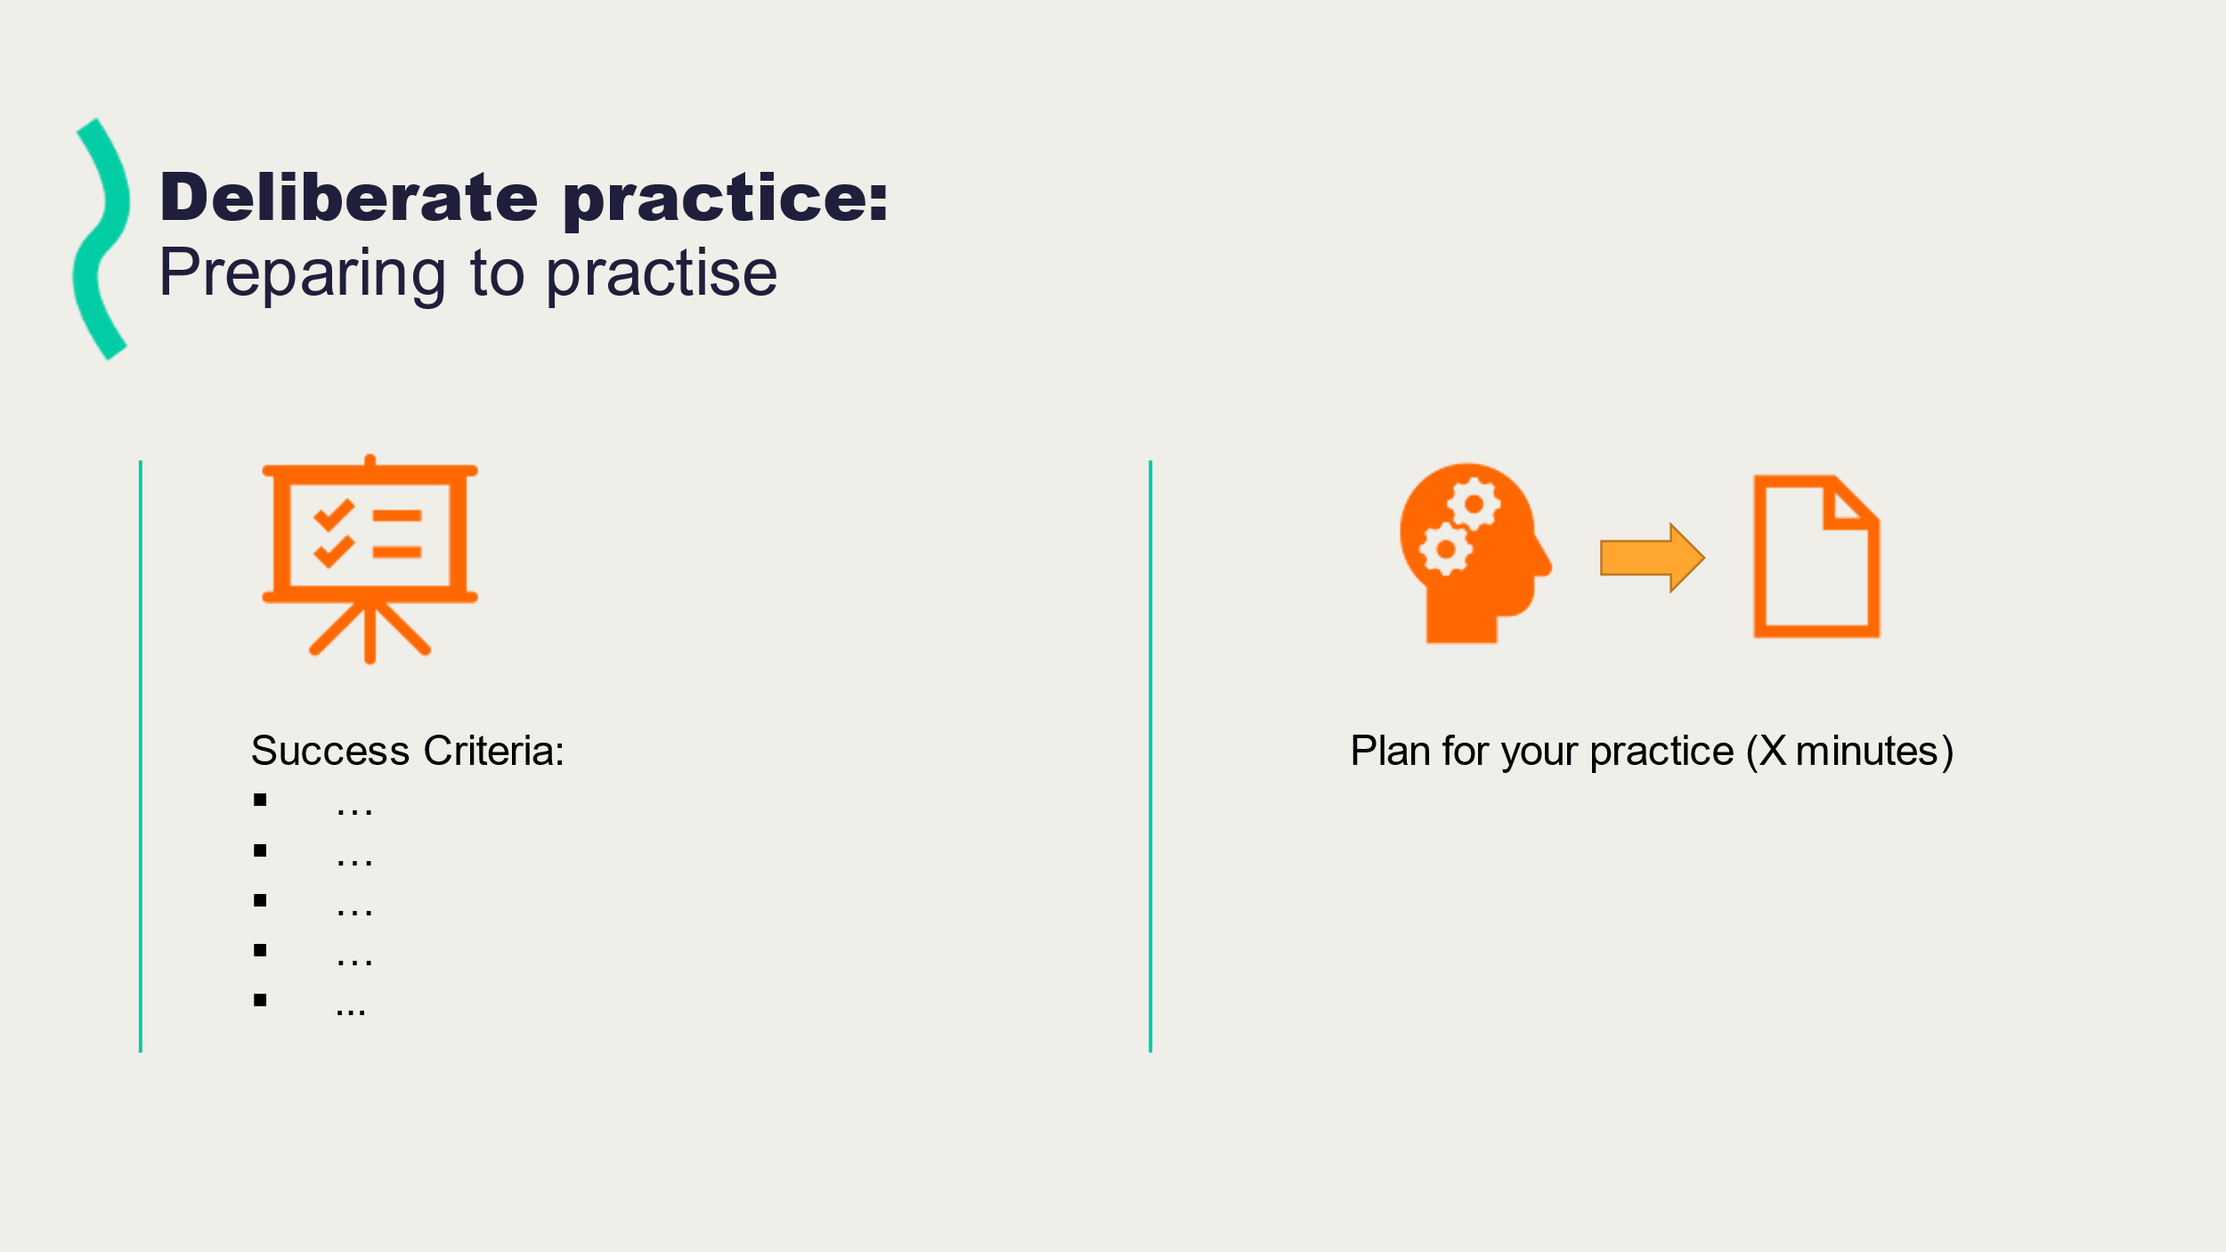
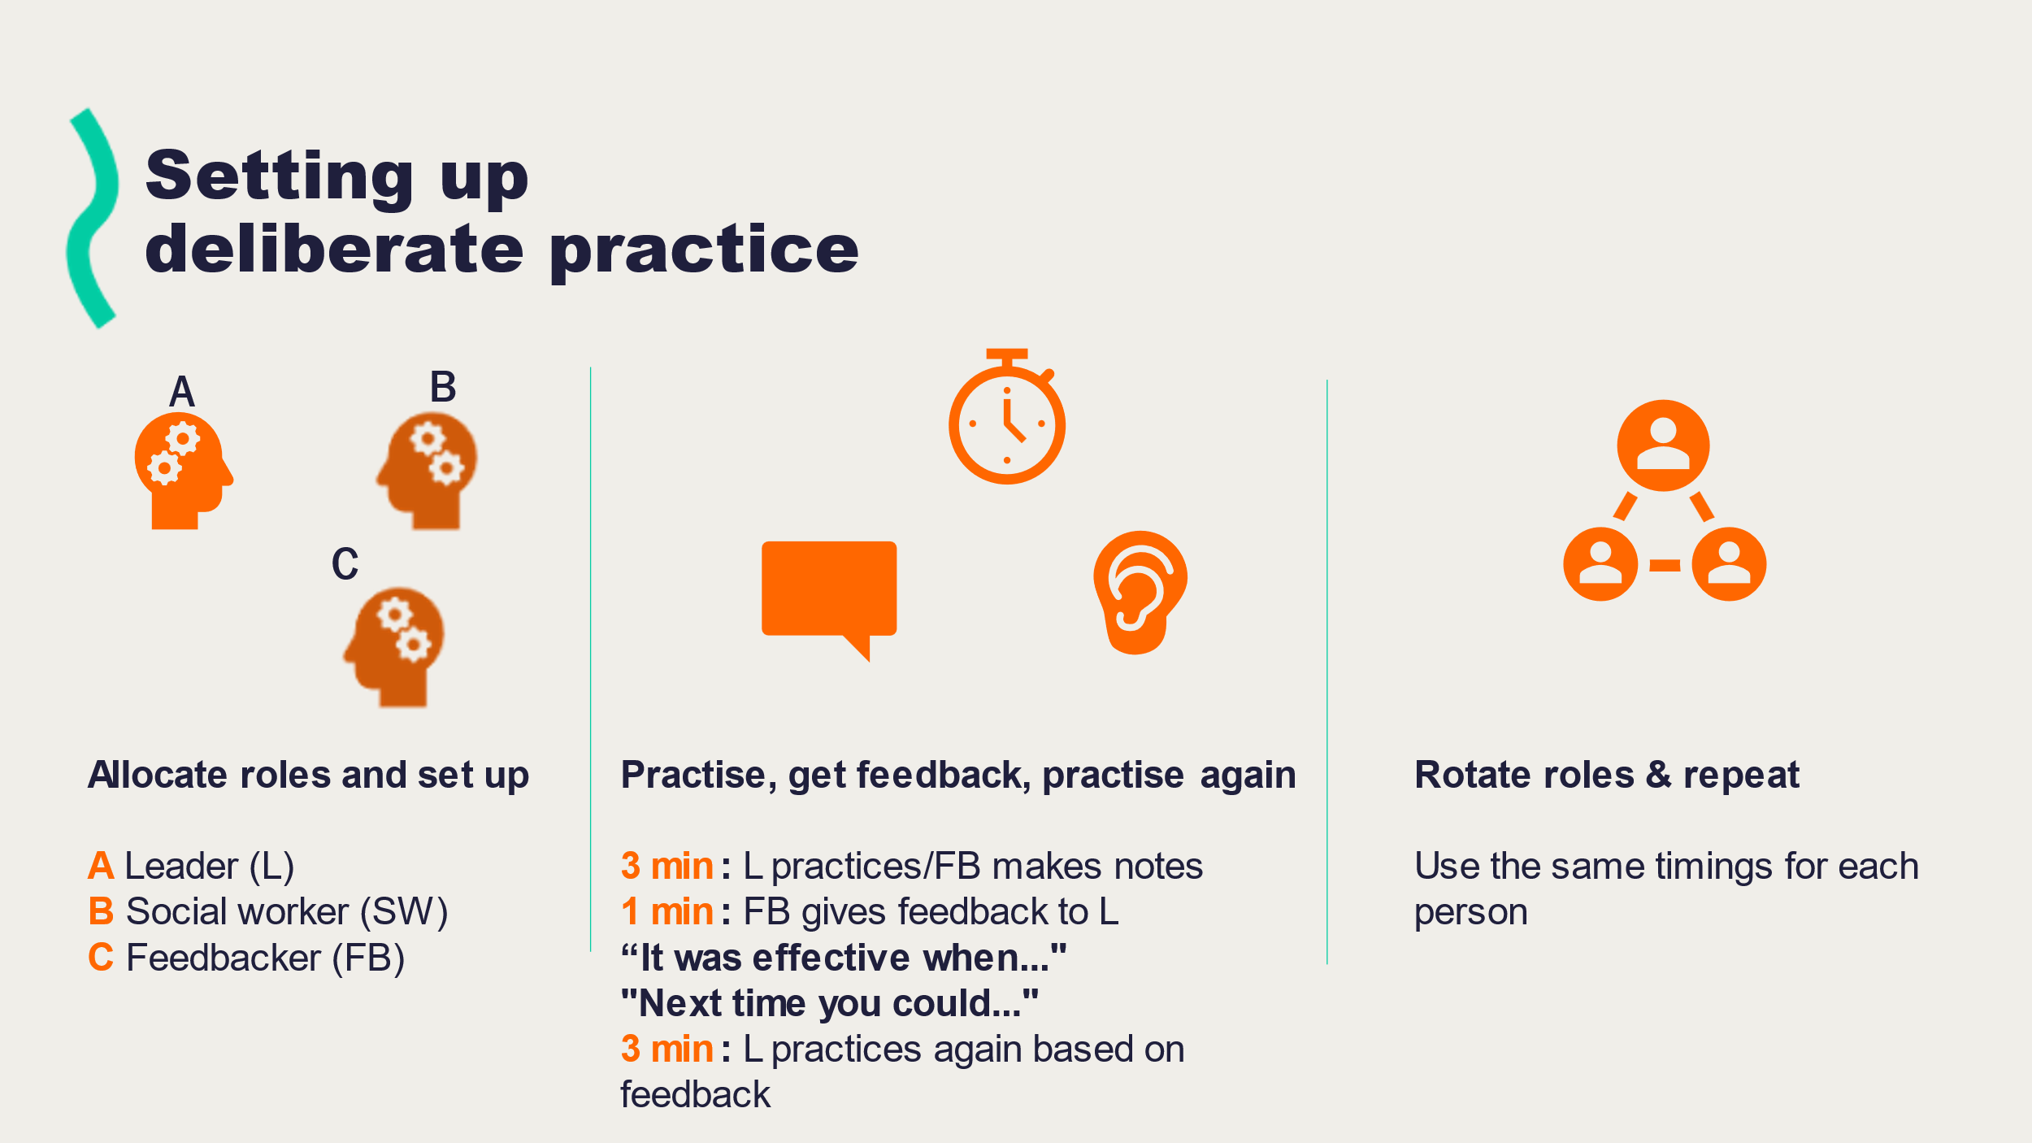

Further reading and references:
- The research publication that first defined deliberate practice:
Ericsson, K. A., Krampe, R. T., & Tesch-Römer, C. (1993). The role of deliberate practice in the acquisition of expert performance. Psychological Review, 100(3), 363–406. doi:10.1037/0033-295X.100.3.363

- A short video (less than three minutes) explaining why deliberate practice is so valuable for training therapists.
The Essentials of Deliberate Practice (APA Press) https://www.youtube.com/watch?v=5ogDHRqiHgs
- A review of using deliberate practice for social work field education.
Gill, K (2019) Deliberate Practice: A Framework for Enhancing Competence in Field Education. Field Education, Volume 9.1 Available online at https://fieldeducator.simmons.edu/issue/volume-9-1-spring-2019/ (Accessed 9th March 2022)

- An easy to read blog explaining deliberate practice
Clear, J (2022) Deliberate Practice: What It Is and How to Use It. Available online at: https://jamesclear.com/deliberate-practice-theory#:~:text=Deliberate%20practice%20refers%20to%20a,specific%20goal%20of%20improving%20performance. (Accessed 9th March 2022)

- Doug Lemov’s book outlining in detail how to implement deliberate practice.
Lemov, D., Woolway, E. and Yezzi, K. (2012) Practice Perfect. 1st edn. Wiley. Available at: https://www.perlego.com/book/1012129/practice-perfect-pdf (Accessed: 25 September 2021).

- Sentio University website – their online home for sharing their work in using a deliberate practice approach to therapy training. Here you can find videos and also books of deliberate practice exercises covering areas such as motivational interviewing and systemic family therapy.
https://sentio.org/

