Deliberate Practice Session 3: Leader-led session guidance
In deliberate practice sessions so far, LDCs have been asked to deliver sessions linked to other areas of the curriculum to create a rounded experience for leaders to bring theory alive.
This session has been set aside, recognising how the benefits of LDCs responding to the needs and priorities of the individual group builds leadership capacity. We would ask that you still draw on the methodology of deliberate practice, however invite coaches to draw on any practical models, and will invite leaders to bring a specific challenge or scenario to practise.
This may cross-over with previous sessions – practicing feedback conversations, public narrative, conversations around equity, diversity and inclusion – or could extend wider e.g. conversations around wellbeing, influencing across and upwards, practicing a coaching conversation.

What are the outcomes of your deliberate practice session with leaders?
By the end of your session, leaders will have:
- Deliberately practised their identified area
- Received feedback from their coach and peers and had the opportunity to re-practise based on that feedback
- Developed confidence and the ability to address areas of EDI within their practice

If Leaders are having difficulty identifying a scenario…
If any leaders are having difficulty identifying a scenario to work on, you could remind them of some of the key themes they have covered, previous exercises, or reflect on a conversation/exchange they have had that they wished had gone differently.
We wanted to share some guidance for one potential route to take if there is a requirement for more structure in the session.
A theme we have visited throughout the Pathway 2 curriculum is resilience and wellbeing so this may be one common area leaders could draw easily on.
Self-study module: Some leaders will have completed a self-selected module on ‘Surviving and thriving as a leader in children’s social care’ as part of their options. Below are the key areas that were covered.
By the end of this module, you will have understood and reflected on:
- Issues of wellbeing as a children’s services leader.
- Systems of support
- Building your wellbeing toolkit.
- Enhancing hope and meaning.

Dates and times
- Running between 1 and 26 April 2024
- 1.5-hour session

How might you structure it?
Structure and timekeeping will support you to give leaders equal opportunity and feedback from the group so we would recommend outlining the time each scenario would be given.
- Warm the context – 7 minutes
- Share the outcomes (see above)
- Explain how the session will the structured
- Invite reflections to identify if the proposed structure will suit or if a more structured topic-led approach will be required
- Practice time – 75 minutes (approx 15 minutes per leader). Please note that during the set-up period, the leader will use their preparation sheet and communicate 3 areas to others
- The area I would like to practice and what I want to achieve
- The people I am speaking to
- The success criteria on which I would like feedback
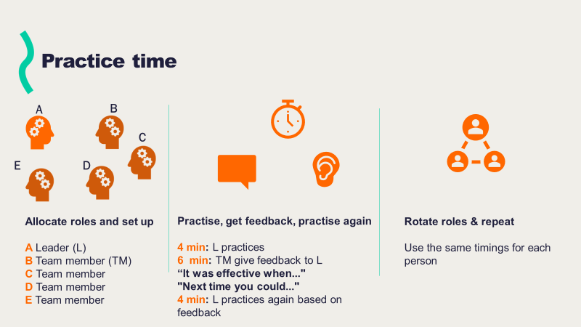

- Reflection and debrief
- How they found the process from planning and thinking of an example to the session itself
- What they have learned from others and what they will do next

What snags or sticking points might you want to be aware of?
- The session becoming an open discussion forum – as this is the final session, you could encourage the group to retain these relationships and space for future discussion and remind them that this is a practical space
- Not sticking to timings – could ask a person for each round to keep timings or set timer on a phone
- Coming without any inspiration – could ask them to go last so they have some opportunity to see how others have done it
- Not wanting to ‘do it’ – allay fears by creating a safe space, discussing the benefits of practice and how it’s an opportunity to ‘fly the plane without any passengers on it!’

What has been shared with leaders?

Preparing for your deliberate practice (leaders’ template shared on the learning platform)
This is an opportunity to practice something that you need to say to an individual or group. For this session, we invite you to consider any area of development from the programme or your role you would find helpful to practice.
This could be related to one of our previous topics (giving feedback, practising your public narrative, conversations around EDI) or could draw more widely on conversations or challenges you are having in your role. Some further examples of this might be influencing upwards, influencing across or with external agency colleagues, or conversations about wellbeing with staff.
Please complete this document and bring it to your deliberate practice session to help you get the most out of the session. There is an example on the second page that might be useful to refer to.

Context setting | Details
The area I would like to practice is:
What I want to achieve is:
The person(s) I am speaking to is/are:
The success criteria that I would feedback on is/are (no more than 3 areas):
Please use the space below to plan for your practice (please note that there is no need for others to play a role)

An example from our previous session:
Context setting | Details
The area I would like to practice is:  What I want to achieve is: | Opening up a conversation in group supervision with my supervisees about the concept of vicarious resilience and how it might benefit our individual and collective wellbeing.  There is a very established narrative around vicarious trauma in the team, however I would like to create room for my supervisees to explore vicarious resilience by contrast and feel safe in discussing what they can learn from it, so in the long term they see the power of changing our narratives.
Self and the person(s) I am speaking to are: | My team members are made up of 5 social workers and one advanced practitioner who are working in family safeguarding. As this is a well-established team with some key longstanding members, I am aware that there can be a fixed mindset approach to things and am mindful of how I navigate that while remaining respectful of their thinking.
The success criteria that I would feedback on is/are (no more than 3 areas): | - Understanding that my team members will have different perspectives and experience in relation to trauma and resilience  - Clarity about what the benefits of vicarious resilience look like in practice  - Curiosity in terms of allowing space for people to share their thoughts
Please use the space below to plan for your practice (please note that there is no need for others to play a role)
Recognise that we have different perspectives on this concept within the group. That we can learn from each other and can only do this if we feel safe to communicate where we are at and any challenges or barriers we may be facing.
Recognise that we need to be respectful, and open to others and that we should maintain curiosity while being sensitive to others and that there will be an opportunity to debrief at the end about how people felt about the introduction of this concept in the supervisory space.
Share some detail about the concept:
Vicarious resilience
Whilst concepts of vicarious trauma are well known throughout the profession, there is also a concept of vicarious resilience
Hernandez-Wolfe, Pillar (2018)

- This concept highlights how, as well as being affected by the trauma of service users’ experience, as professionals we can also learn from those we work with and be positively affected by people’s strength, and how children and families cope with adverse events.
- Whilst there are complexities to this idea and you might want to develop your understanding further, examples of the learning for professionals cited include:
- Changes in life goals and perspectives
- Client-inspired hope
- Increased self-awareness and self-care practices
- Increased capacity for resourcefulness
- Increased recognition of spirituality as a therapeutic resource
- Increased consciousness of power relative to social location

Pause and ask team members for their thoughts and reflections.

